DATA COLLECTION DRAFT 1
Dragon Link | (Happy Prosperous) (Peace & Long Life) (Panda Magic) (Autumn Moon) (Genghis Khan) ( Silk Road) (Spring Festival) (Golden Bong)
Lightening Link | (Wild Chuco) Tiki Fire) (Bengal Treasures) (Magic Totem) (Aussie Boomer) (Miner)
Dragon Train Link
Super Grand Star Link
Bull Rush Link
Monopoly
Huff n Puff
Thunder Link | (Inca Diamonds) (Thunder Kingdom) (Samari King) (Mongolian Express)

- Machine Names
- Dragon Link (Happy Prosperous) (Peace & Long Life) (Panda Magic) (Autumn Moon) (Genghis Khan) ( Silk Road) (Spring Festival) (Golden Bong)
- Lightening Link (Wild Chuco) Tiki Fire) (Bengal Treasures) (Magic Totem)
- Dragon Train Link
- Super Grand Star Link
- Bull Rush Link
- Monopoly
- Huff n Puff
- Piggy Bankin
- Thunder Link (Inca Diamonds) (Thunder Kingdom) (Samari King) (Mongolian Express)
- Royal Spark

- App Features
- Win amount box clear (to be left clear and filled in and collected and stored) Automatically detected AI
- Bet amount box clear (to be left clear and filled in and collected and stored) Automatically detected AI
- Lines box clear (to be left clear and filled in and collected and stored) Automatically detected AI
- Machine Name Box clear (to be left clear and filled in and collected and stored) Automatically detected AI
- Bonus Feature Hit tick Box
- Spins Since Last Bonus Box clear (to be left clear and filled in and collected and stored) Automatically detected AI
- Graph for Win Clusters & Bonus Clusters Automatically detected AI
- Graph for Hot & Cold Machines Automatically detected AI
- Chat Forum with a side attachment (Leader Board Grand Jackpot recent wins)
- AI Automatic Video Recognition (Pattern and number recognition and Spin Button recognition)

- App Security
- Video feed cuts out when camera is not on screen
- Video feed cuts out if someone walks in front while recording
- Ai detection can only focus on screen
- Disclaimer
- Responsible Gambling Help Tab Link
- Faults and Complaints Tab directed to email

1. Verbal Consent Script (Best Practice)
Before filming, ask the player directly. This is the safest method to avoid security intervention or accusations of harassment.
"Hi, I am conducting a study on gaming machine interfaces for data analysis. I'm recording screen footage only (no audio/no face) to analyze how the machine works. I will not be filming your face, personal data, or your face/identity. Is it okay if I record this 5-minute session? I can delete it immediately if you change your mind."
2. Physical Signage/Disclaimer (For Situational Use)
If you are recording in a corner of a club, you should display a sign nearby so players are aware.
⚠️ NOTICE: DATA COLLECTION IN PROGRESS
Video recording is occurring in this area for research/data collection purposes.
- What is recorded: Screen footage of the gambling machine only.
- What is NOT recorded: Faces, audio, or identifiable personal information.
- Purpose: Interface analysis.
- Privacy: All footage is de-identified immediately and used only for data analysis.
- If you do not wish to be included, please ask the operator to pause recording.

3. "No Faces" Privacy Disclaimer (For Data Security)
If you are analyzing the machine's behavior and not the player's behavior, use this.
"This recording is for technical data collection of machine game play. Every effort is made to ensure that no faces, personal identifying information, or financial information (like cards/banknotes) are captured. The footage will be used for research purposes only and will not be shared publicly."

Critical Advice for Data Collection in Australian Pokie Rooms
- Venue Policies: Most venues prohibit filming to prevent the capturing of patron faces. Get permission from club management first, or security will likely stop you.
- Audio Risks: Recording audio (conversation) without consent is illegal in many Australian states. Turn off your microphone.
- No Identifying Info: Never capture screen shots of cash-out tickets, identification, or credit card details.
- Privacy Act: If you are conducting research, you are bound by privacy principles (OAIC) regarding how you handle the personal information collected.
- What to do if asked to stop: If a stranger or security asks you to stop, stop immediately, delete the footage, and leave.

- App Launch Strategy
- Locally find 100 users (Local Launch)
- Launch online (TikTok) (Face book) (Instagram)
- Scale to market
- Research Competition and User Market

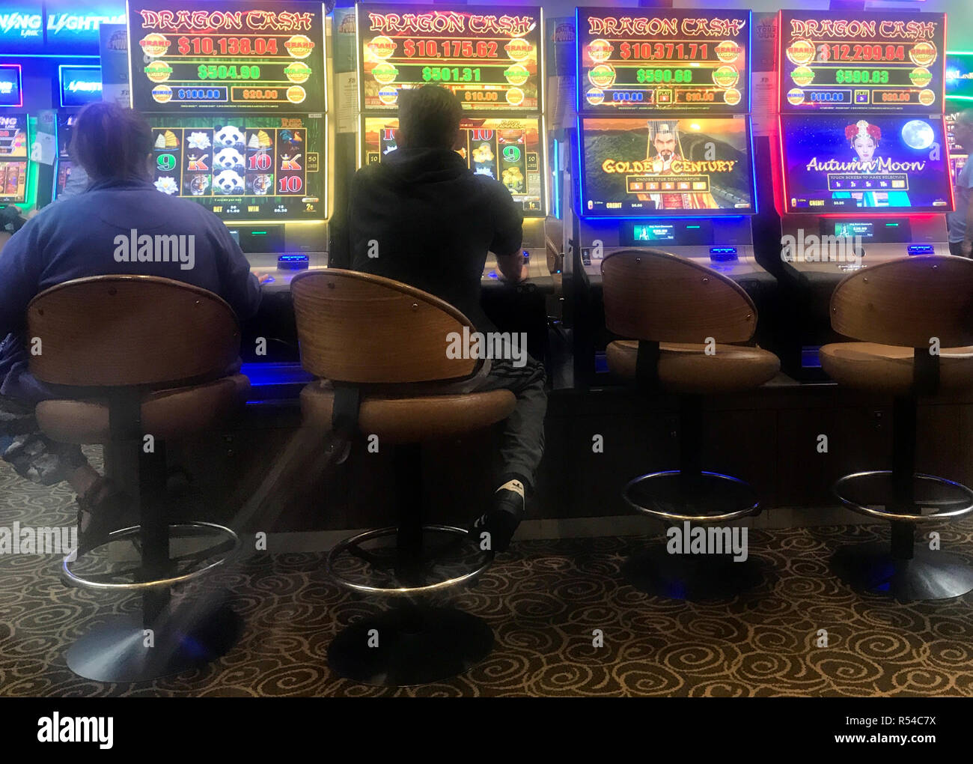
POKIE ANALIZER
Dash-Board Interface
Grand Jackpot
$
Major
Jackpot
$

Bet Amount $1.00 - $5.00

DENOMINATIONS | 1 Cent | 2 Cent | 5 Cent | 10 Cent | 20 Cent | $1 Dollar
Box’s to be ticked

$1 Bet amount | $2 Bet  amount | $3 Bet  amount | 4$ Bet  amount | 5$ Bet  amount | Total  Balance  $ | Win Amount  $ | Bonus Feature  Clusters
1 Lines | 2 Lines | 3 Lines | 4 Lines | 5 Lines | Spins Since Last Bonus  Feature | Win Clusters | Graph  Hot & Cold Machines

